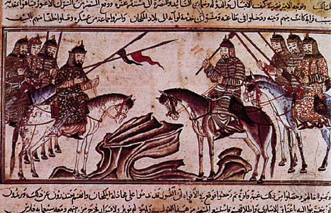

- Karakorum
- Pastoralists
- Kumiss
- Shamans
- Saljuq (Seljuk) Turks
- Khan
- Battle of Manzikert
- Mahmud of Ghazni
- Sultanate of Delhi
- Temujin/Chinggis (Genghis) Kahn
- Khubilai Kahn
- Marco Polo
- Yuan Dynasty
- Kamikaze
- The Golden Horde
- Ilkhanate
- Lamaist Buddhism
- Bubonic Plague/Black Death
- Timur-i-lang/Tamerlane
- Osman
- Ottoman Empire
- Mehmed II (The Conqueror)
- Istanbul

PART ONE

Read pp. 360-361 for #1-3
1. Which three big empires built or rebuilt themselves by 1000 CE?

2. Which two important trade networks did they reestablish and further develop?

3. What three world religions spread throughout the Eurasian landmass between 500 and 1000 CE?

4. How did a Parisian goldsmith end up in the Mongol capital of Karakorum?

5. What does this tell us about the vast size and ambitions of the Mongol Empire?

6. Briefly describe the life and lifestyle of the nomads of the Eurasian steppes.

7. What is kumiss? What are yurts?

8. Why did nomads trade with settled agricultural societies and empires?

9. What were the two classes in nomadic society? Was there a possibility of social mobility?

10. Briefly describe the role of women in nomadic society.

11. Briefly describe early nomadic religion.

12. Why were nomads effective and fearsome warriors? What does Kahn mean?

13. Read “William of Rubruck on Gender Relations among the Mongols” Why did women play such prominent social and economic roles in nomadic pastoral society?

14. How did the Saljuq (Seljuk) Turks come to serve then dominate the Abbasid Empire?

15. Briefly describe the development of the Sultanate of Delhi.

16. How did Mahmud of Ghazni treat Hindus and Muslims under his rule?

17. Describe Temujin’s rough childhood and early life?

18. How did Temujin unite the Mongol tribes into a nation?

19. What does “Chinggis Khan” mean? How did he organize his army?

20. Briefly describe Mongol battle tactics.

21. How did the Mongols treat the people they conquered?

22. Briefly describe the Mongol conquest of Northern China?

23. Why do you think Chingiss Khan was particularly brutal in his conquest of the Khwarazm lands?

24. When did Chingiss Khan die?
Read “Marco Polo on Mongol Military Tactics” (p. 371)
25. In what way do the military practices described by Marco Polo reflect the influence of the steppe environment on the Mongols?

26. Does Marco Polo seem to admire or condemn the Mongol tactics?

PART TWO

1. Name the four regional empires that developed from Chinggis Khan’s empire after his death.

2. Which of Chinggis Khan’s grandsons conquered the Southern Song Empire?
3. What name did he give to his new dynasty?
4. Describe some of his attempted conquests.

5. Why did he fail to conquer Japan?

6. Briefly describe the conquests of the Golden Horde.

7. How did they control Russia?

8. Briefly describe the conquests of the Ilkhanate. How were they stopped?

9. How did the Ilkhanate administer their empire? What religion did they eventually join?

10. Briefly describe how the Mongols ruled China.

11. What form of Buddhism did they favor? Why?

12. How did the Mongols facilitate trade within their vast empire(s) and beyond?

13. Why does your text say that the Mongols “sponsored interaction…more than ever before”? Why does this matter?

14. Why did the Mongols tend to favor religious tolerance?

15. Why do you think the Mongols recruited (or forced) skilled artisans and experienced government administrators to serve in their empire(s)?

16. How did the economy of Mongol-ruled China decline?

17. When did the Bubonic Plague hit China? Western Asia & Europe? What was it called in Europe?

18. Briefly describe the rise of Tamerlane.

19. Briefly describe his conquests.

20. Why do you think his empire did not endure?

21. Who was Osman? What was his empire called?

22. How did Osman begin to carve out an empire? What weakening empire (by the 1300s) did he attack?

23. Why did local Byzantine citizens often welcome their Ottoman conquerors more as liberators?
24. Why did the Ottomans experience a temporary setback?

25. When did the Ottomans conquer Constantinople? Who was their leader at this point?

26. What new name did they give to the city of Constantinople?

