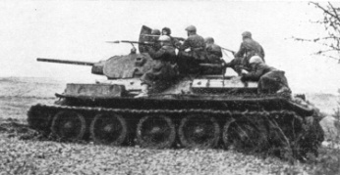
WORLD HISTORY AP (WHAP) CHAPTER 30
Part One: Vocabulary
Put these on flash cards! If you don’t want to do flash cards, you can write out some definitions and turn them in – but I think flash cards are the best idea.
Afrikaner National Party | Algeria | apartheid | Atlantic Charter
Axis Powers | Battle of Britain | battle of Coral Sea | Battle of Stalingrad
Battle of the Bulge | blitzkrieg | Cold War | Eisenhower
Erwin Rommel | Final Solution | Franklin Roosevelt | Ghana
Hiroshima and Nagasaki | Holocaust | Indian National Congress | Jomo Kenyatta
Kenyan African Union | Kwame Nkrumah | Land Freedom Army | Manchukuo
Manchuria | Midway Island | Mohandas Gandhi | Muhammad Ali Jinnah
Muslim League | National Socialist Party | Neville Chamberlain | Nonaggression Pact
OAS | Potsdam Conference | Quit India Movement | South Africa
Stafford Cripps | Tehran Conference | total war | Tripartite Pact
United Nations | Vichy | Wannsee Conference | Wehrmacht
Winston Churchill | World Court of Justice | Yalta Conference | Isoroku Yamamoto
Part Two: Questions (Paragraph Responses – these are the big ideas!)
- Was World War II inevitable?? (opinion alert!!)
- Compare the strategies and tactics of World War I to World War II.
- Compare the German’s policy toward Jews and the Japanese policy toward the Chinese.
- What led to initial Axis successes?
- Why were the Germans and Japanese able to sustain their initial success?
- What role did the USSR play in the Allied victory?
- How did war conferences lead to Cold War tensions?
- Can you think of any ways that would have kept India from splitting after independence?
- How did the United Nations’ plan for peace in the Middle East differ from what actually occurred?
