CHAPTER 31: THE COLD WAR IN THE WEST
Eastern bloc | Iron Curtain | Berlin Wall | Marshall Plan
NATO | Warsaw Pact | CIA | North Korea
Aleksandr Solzhenitsyn | Vietnam | Sputnik | de-Stalinization
Containment | decolonization | brinkmanship | liberal democracy
Welfare state | Marshall Tito | Harry Truman | Nikita Khrushchev
European Union | Common Market | Solidarity | Green movement
Great Society | Civil Rights movement | Ronald Reagan | George H. W. Bush
Bill Clinton | Christian Democratic Party | The Beatles | Watson and Crick
Betty Friedan | New Feminism | Simone de Beauvoir | Ingmar Bergman

- Compare Western and Soviet responses during the Cold War.
- Trace the changing views about the role of women in the West during this era.
- Both sides blame each other for starting the Cold War. What were their arguments?
- What was the purpose and the outcomes of the Marshall Plan?
- What positive and negative effects did the welfare state have?
- How did the Soviet Union take advantage of its Eastern European satellite states?
- What were some successes of the Communist model, and what were some ways that Communism was unable to compete with capitalist economies?
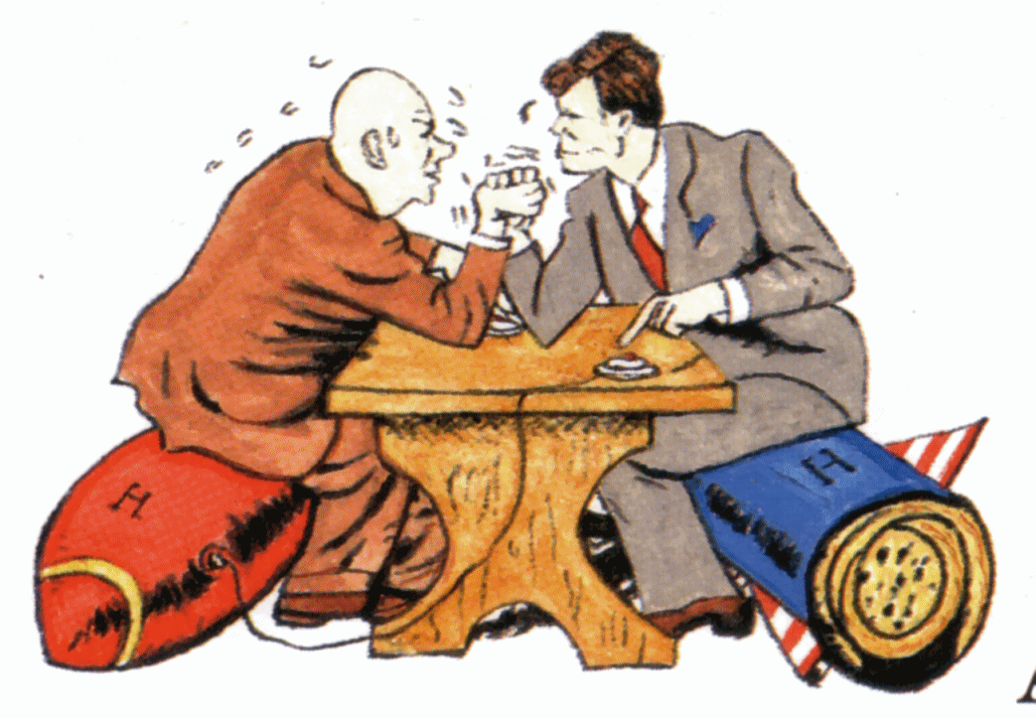
- Rank the following Beatles albums in order of their awesomeness, from most awesome to least awesome:
Sgt. Pepper’s Lonely Hearts Club Band, Abbey Road, Revolver, Rubber Soul, The White Album.

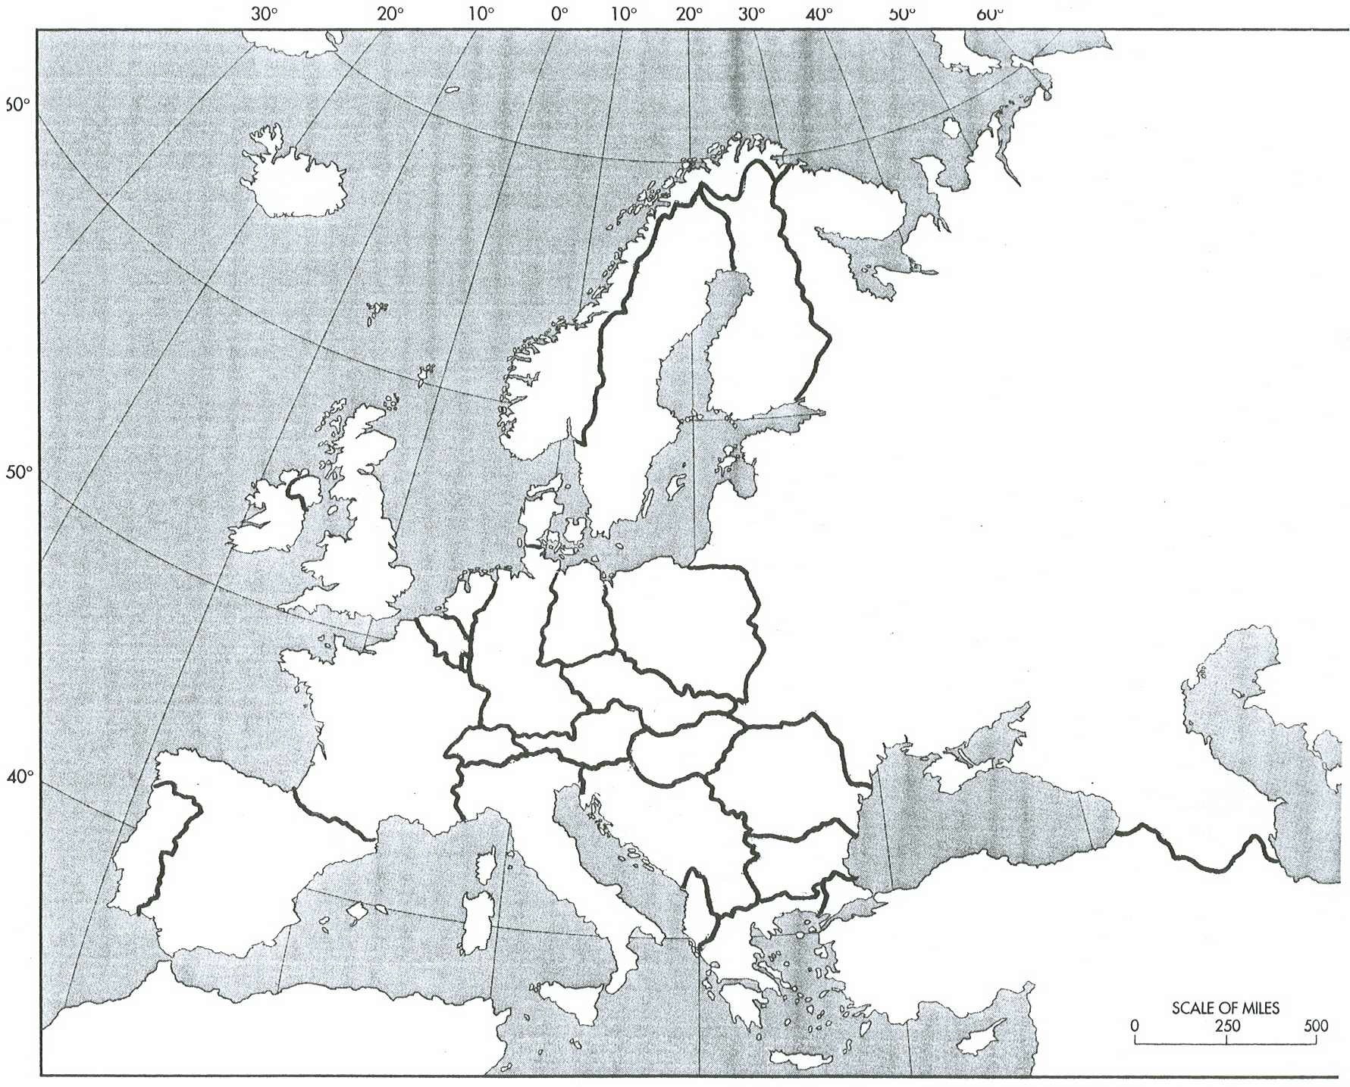
Label each of the nations on this Cold War era map. Shade in the NATO powers, the Warsaw Pact countries (different color) and leave the neutral countries blank.

